Normal Chart

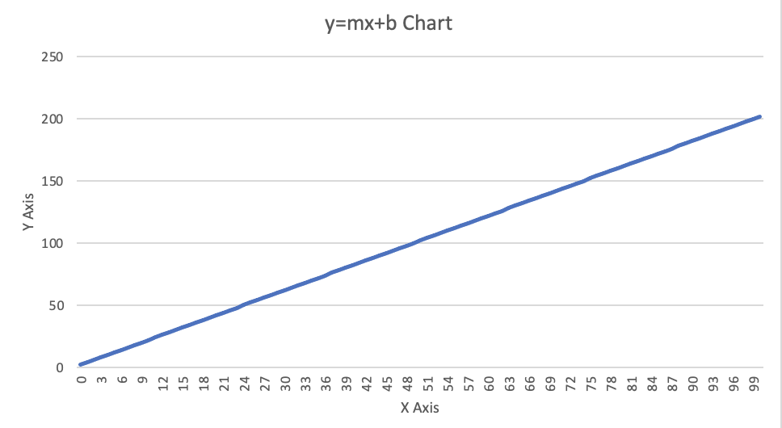

This is my y=mx+b chart and I created it by using two different array lists, one for the x axis and then one for the y axis. The x axis was created in a for loop from 0 to 100 and for each element, an integer is added to the x axis array list. The for loop for the y axis was a little different to generate its values. The y axis was also from 0 to 100 and I used the y=mx+b equation to generate the y axis values. I then had a final for loop that would get the values from both the x and y axis and write it to a file using printwriter. Once this was done, I was able to open the csv I created in excel and create the graph that is depicted above.

Salted Chart

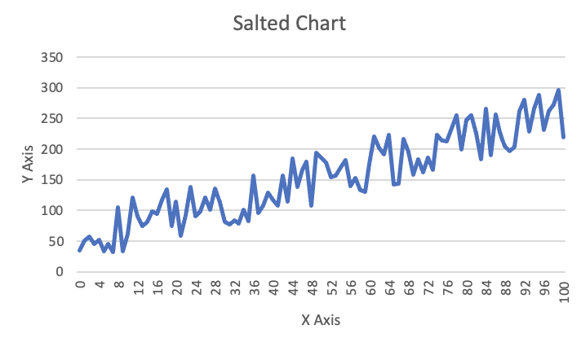

The graph above depicts the salted chart that I created. I was able to do this by reading the original chart’s csv file by using bufferedreader, and then parsing the integer values by using a while loop. To salt the data, you keep the x values the same but you want to make the y values volatile so you can get a noise-ridden chart like the one you see above. To properly salt the data, I created a random number generator between the values of 10 and 20. I then used an if loop to add a different random value to every other y point in the graph. Finally, I had a for-each loop that was able to get each value from the x axis array list and y axis array list and write it out to a csv file. Ultimately, creating a volatile graph that is filled with noise and sporadic y points that is shown above.

Smoother Chart

To create a smoother chart, I used a bufferedreader to read the salted chart file and extract the data points. Next, I implemented a for loop to traverse each value on the y axis and calculated the average. This was done by adding all values with a specific y value and its five neighboring y values, and then dividing by the total number of values. The moving average then replaced the original set of y values by using the set method. Once this was done, the result was a much smoother graph than the original salted graph. However, I did have to repeat this process several times to get a smoother line. There were also some challenges in smoothing out the first and last values, which remained slightly jagged. Despite this, the overall result showed a significant improvement in the graph's smoothness, as can be seen in the image depicted above.